Mugginton Church of England Primary School
Children’s Anti-Bullying Policy

Our definition of bullying:
‘Bullying is when someone, adult or child, chooses to repeatedly pick on somebody and hurt them physically or mentally because of how they look, speak or act, even after they have been asked to stop.’

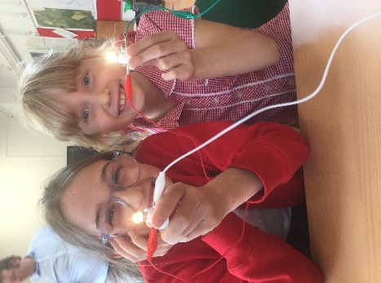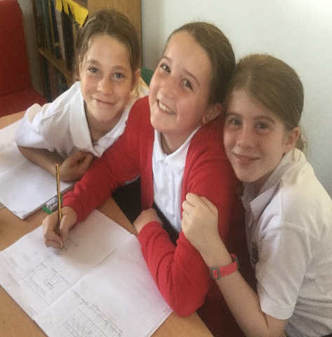
What we Believe at Mugginton
At Mugginton we believe everybody should have the same opportunities. We treat people how we want to be treated and we know that everybody is different and everybody is special. We believe every child should feel safe and happy and we know we can tell any adult or a friend if we don’t feel safe.
What is Bullying?
‘Bullying is when someone, adult or child, chooses to repeatedly pick on somebody and hurt them physically or mentally because of how they look, speak or act, even after they have been asked to stop.’
Types of Bullying
Bullying of any sort is NEVER acceptable. Bullying can happen in school, on the playground or outside of school. Whenever it happens, it is wrong. If you ever experience bullying or feel unsafe, you must tell somebody as soon as you can.
Physical Bullying 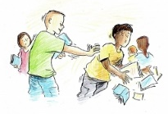 | Physical bullying is using your body to hurt another person. For example, kicking, pushing, punching or using threatening behaviour.  The effects of physical bullying are easy to spot. For example, bruises or cuts.
Verbal Bullying  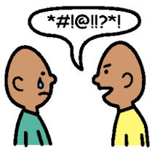 | Verbal bullying is using unkind or hurtful words to gain power over a person. For example, name calling, teasing, swearing and homophobic or racist words.  The effects of verbal bullying are hard to spot because it often happens away from adults.
Social Bullying | Social bullying is when people try to embarrass or humiliate another person. For example, by spreading rumours, lying, gossiping, leaving people out.  It is very hard to spot because it is often done behind a person’s back.
Cyber Bullying  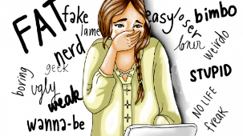 | Cyber bullying is bullying using electronics such as mobile phones, computers, games consoles, IPads and other tablets. For example, sending nasty messages, using aggressive words, sharing private information, threatening the person, teasing them, criticising and spreading nasty rumours about them.
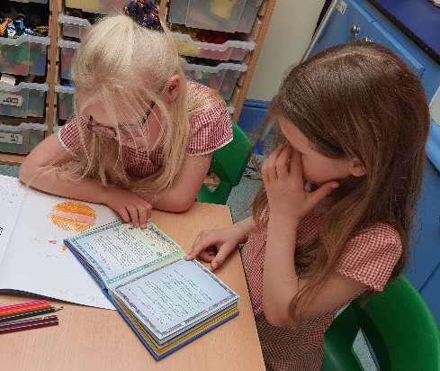
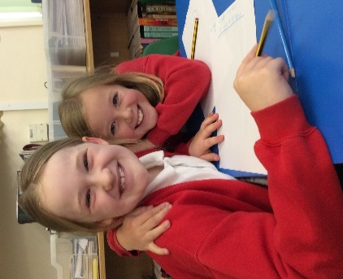
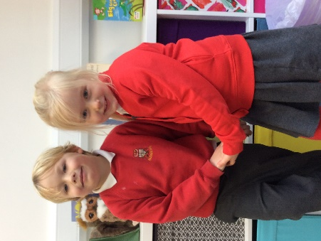

What should I do if I am being bullied?
Try to | Try not to
- Tell somebody straight away  - Ask them to stop, if you can  - Try to write down exactly what happens and when  - Be proud of who you are – it IS NOT your fault  - Be with people who are kind and make you feel happy | - Get upset  - Respond by hitting or saying something nasty back  - Keep it to yourself, you must tell somebody so we can help you  - Think it’s your fault and take it personally. Bullying is NEVER right

What should I do if I see somebody being bullied?
- Tell somebody straight away – you do not need to get involved if you don’t feel safe

- Check that the person being bullied is okay

- Do not keep quiet or bullying will keep happening
Speak out, Speak out, Speak out!
Telling somebody that you or somebody else is being bullied can be difficult. However,
- We all have a responsibility to make sure that bullying never happens at our school
- Telling somebody is the right thing to do
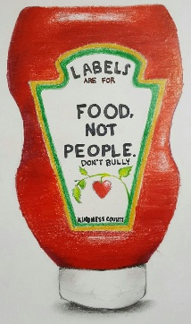
- The teachers and Mr Green will deal with it calmly, sensitively and quickly. Teachers will tell you what is going to happen next and will make sure you are ok
- If nobody knows what is happening, nobody can help
- We are a family and need to support each other
- Don’t ever feel embarrassed about feeling unsafe. It is NEVER your fault
Who can you tell?
Your Teacher: They know and care about you and can give you support every day
Any other staff: We all know each other so well that you can tell any adult and we will all help you
A friend you trust: Talking about things you worry about makes you feel better. Real friends will look after you and make you feel better. They can help you to talk to an adult
An older pupil: They will help you to talk to an adult and will make you feel better
A parent, a friend or somebody else you trust: If you don’t want to talk to anybody at school, tell somebody at home. They can
What our teachers will do to help you
We will take all things you tell us seriously and listen to you. We will write down what you tell us
We will be sensitive to your situation
We will not stop until the bullying has stopped
We will explain to children why bullying is wrong
We will try to make you feel right again. Remember bullying is never your fault
We might speak to your parents so they can help too
We will continue to monitor the situation afterwards and check that things have changed
We will continue to talk about anti-bullying so everybody continues to feel safe and happy at school

If you are being bullied at home or in school, remember:

START TELLING OTHER PEOPLE

