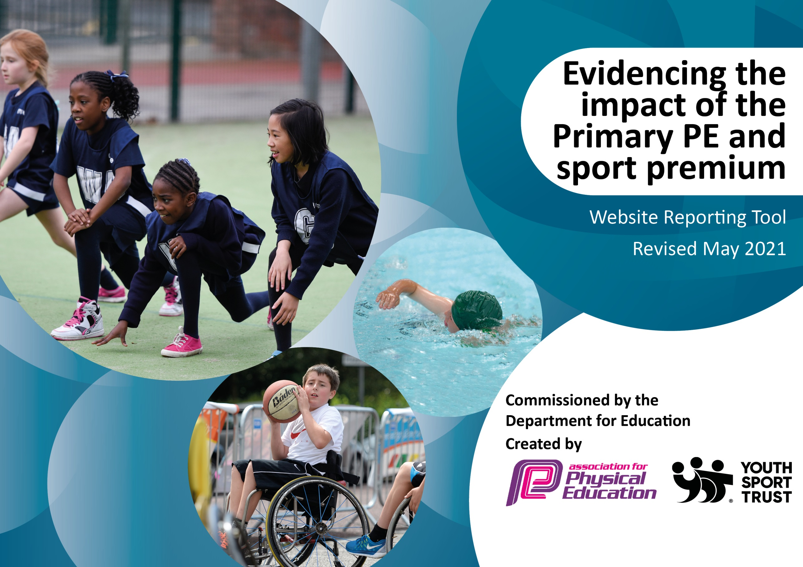

It is important that your grant is used effectively and based on school need. The Education Inspection Framework (Ofsted 2019 p64) makes clear there will be a focus on ‘whether leaders and those responsible for governors all understand their respective roles and perform these in a way that enhances the effectiveness of the school’.

Under the Quality of Education criteria (p41) inspectors consider the extent to which schools can articulate their curriculum (INTENT), construct their curriculum (IMPLEMENTATION) and demonstrate the outcomes which result (IMPACT).

To assist schools with common transferable language this template has been developed to utilise the same three headings which should make your plans easily transferable between working documents.

Schools must use the funding to make additional and sustainable improvements to the quality of Physical Education, School Sport and Physical Activity (PESSPA) they offer. This means that you should use the Primary PE and sport premium to:

- Develop or add to the PESSPA activities that your school already offer
- Build capacity and capability within the school to ensure that improvements made now will benefit pupils joining the school in future years
- The Primary PE and sport premium should not be used to fund capital spend projects; the school’s budget should fund these.
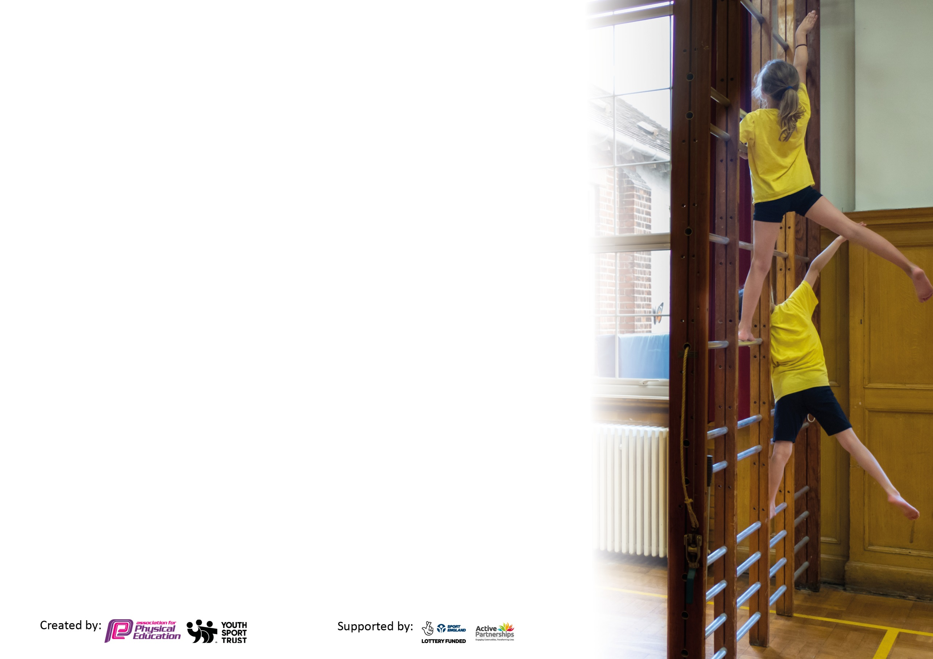
Please visit gov.uk for the revised DfE guidance including the 5 key indicators across which schools should demonstrate an improvement. This document will help you to review your provision and to report your spend. DfE encourages schools to use this template as an effective way of meeting the reporting requirements of the Primary PE and sport premium.

We recommend you start by reflecting on the impact of current provision and reviewing the previous spend.

Schools are required to publish details of how they spend this funding, including any under-spend from 2020/2021, as well as on the impact it has on pupils’ PE and sport participation and attainment by the end of the summer term or by 31st July 2021 at the latest.

We recommend regularly updating the table and publishing it on your website throughout the year. This evidences your ongoing self-evaluation of how you are using the funding to secure maximum, sustainable impact. Final copy must be posted on your website by the end of the academic year and no later than the 31st July 2021. To see an example of how to complete the table please click HERE.

N.B. In this section you should refer to any adjustments you might have made due to Covid-19 and how these will influence further improvement.
Support for review and reflection - considering the 5 key indicators from DfE, what development needs are a priority for your setting and your pupils now and why? Use the space below to reflect on previous spend and key achievements and areas for development.
Key achievements to date until July 2021: | Areas for further improvement and baseline evidence of need:
Funding of specialist PE providers: Premier Sport. Instructors have developed long term plans and delivered activities which have offered children new sporting experiences such as Fencing, Dance and Archery and assess pupils’ progress on a half-termly basis via their BMS online system.  Premier support the specific curriculum intent of our school, also synchronising with the National Curriculum purpose and aims for PE. We offer a range of opportunities to support children’s physical and mental development in being creative, confident, and caring. This aligns with our high-quality, inspiring PE curriculum that builds character and an understanding of fairness and respect.  We have been flexible and agile in adapting to the Covid-19 pandemic, opening school as early as possible to allow children to safely return to school as soon as possible. Premier Sports supported us in this aim by making it mandatory for all Activity Professionals to complete a Level 2 Ofqual registered qualification in Infection Prevention, Mitigation and Management. The qualification is sector leading and comprehensive in its content to support working in schools.  We aim to be the most active primary school in the county. Our curriculum is based around a love of the outdoors and we spend every Friday in the forest learning at our outdoor classroom. The children are encouraged to join our two weekly runs, known as the ‘Mugginton Mile’ when staff and parents join the children running differentiated distances of between 1 and 5 kilometres.  At the end of each half-term we offer school & family walks at a selected destination in the Peak District.  We have funded a free after-school sports club every Monday. Children from across the age ranges have attended and the club currently attracts approximately 33% of our pupils.  We have provided quality-assured professional development opportunities for teachers which has ensured high quality teaching and learning for all children. This has been facilitated via training run by the Premier Sport instructors and also by our Higher Level Teaching Assistant, Mr Wraith who is PESS level 3 qualified and a former employee of Premier. Mr Wraith has run both group and 1-1 professional development sessions for all staff.  Despite our small size, we aim to have well-coached, sporting and competitive sports teams. This has resulted in us winning small school AVSSP competitions but always trying our best and playing in a sporting fashion.  Whole school audit of sports equipment has been completed by Mr Wraith. This has allowed us to purchase new, quality sports equipment as required.  Firm links have been made with Woodlands Tennis Club which has resulted in every junior child having weekly tennis sessions in the summer term. We are delighted that at least 10 of the children who attended these sessions are now members of the tennis club.  Our whole school aim in 2021-2022 is for every child in Years 2 – 6 to have the opportunity to represent our school at an inter-school sporting event. Last year, our aim was similar - to increase participation levels in inter- and intra-school competitive sport, once we were able to mix with other schools safely. Due to covid restrictions, however, we were unable to fulfil this aspiration.  We have supported our Outdoor Learning curriculum by running Forest Friday sessions on a weekly basis throughout school year. Forest Friday resources have been funded and transport to and from locations for our whole-school walks with parents.  We have purchased fitbits to help the children refine technique and learn more about a healthy lifestyle. We have identified talented runners and encouraged them to control pace, cadence etc using trackers. The fitbits are used both during the day and during our twice weekly whole school run where we have run distances ranging from a mile to 7 miles! Significantly the minimum participation of eligible children (Years 2 -6) on our runs has been 80%!  High numbers stay for extracurricular activities offered every day of the week. On average 25% of children attend after school clubs. We offer a variety of activities including dance, net and wall games, invasion games, target sports and striking and fielding games.  We have purchased new sports and ‘lunchtime’ equipment, including sports equipment plus specific items that have then been used during dinner time sessions such a ‘hoppers’, wheeled toys and costumes.  All pupils completed ‘Bikeability’ training in June 2021. To build on this, Sports Premium money was used to fund a trip for Years 5 & 6 to Carsington Reservoir to cycle the 8 miles around the following week (supported by staff running and on bikes). Children are aware how to be safe on the road and are encouraged to enjoy cycling with their families and friends.  100% of the junior pupils (Years 3-6) can swim one length (25 metres).  To fund the training and resources for our older pupils to become ‘playground-leaders’ and encourage physical, sporting activity on the playground at lunchtime.  Mr Green and Mr Wraith, a former Sports Instructor, share the role as P.E. Coordinators. Money was set aside and used for training opportunities and resources following a Summer audit. Three Year plan drawn up to improve the playground surface and storage area. Planning application was successful and playground refurbishment plans are at the tendering stage. | 1.The Engagement of all pupils in regular activity  To remind staff of the benefits of the daily mile and other  activity breaks and to monitor their use.  2. The profile of PE and Sport being raised across the school as a tool for whole school improvements  PE noticeboard showing events and achievements.  3.Increased confidence, knowledge and skills of all staff in teaching PE  and sport. Check that all staff are confident in teaching physical activity/PE within a Covid secure environment  4.Broader experience of a range of sports and activities offered to all  pupils.  Need to access a variety of competitions and festivals not  just football  5.Increase participation in competitive sports  Develop more inter school competitions  Develop more intra competitions  CPD for staff  Level of engagement for extra curriculum sports  PE curriculum during COVID  Premier Sport coaching for all children  Increased emphasis on performing dances using both simple and a range of movement patterns.  Plan to improve the surface of the playground area and shed.  All these areas for improvement are subjected to what activities are  allowed in relation to Covid 19 and safety measures.
Did you carry forward an underspend from 2019-20 academic year into the current academic year? YES
Total amount carried forward from 2020/2021 £2,500
+ Total amount for this academic year 2021/2022 £19,041
= Total to be spent by 31st July 2022 £19,041
Meeting national curriculum requirements for swimming and water safety.  N.B Complete this section to your best ability. For example, you might have practised safe self-rescue techniques on dry land which you can transfer to the pool when school swimming restarts.  Due to exceptional circumstances priority should be given to ensuring that pupils can perform safe self-rescue even  if they do not fully meet the first two requirements of the NC programme of study. | Swimming was stopped in March  2020 due to the coronavirus. Swimming re-started in September 2021.
What percentage of your current Year 6 cohort swim competently, confidently and proficiently over a distance of at least 25 metres?  N.B. Even though your pupils may swim in another year please report on their attainment on leaving primary school at the end of the summer term 2021.  Please see note above. | Swimming was stopped in March  2020 due to the coronavirus,  therefore there is no data
What percentage of your current Year 6 cohort use a range of strokes effectively [for example, front crawl, backstroke and breaststroke]?  Please see note above. | Swimming was stopped in March  2020 due to the coronavirus,  therefore there is no data
What percentage of your current Year 6 cohort perform safe self-rescue in different water-based situations? | Swimming was stopped in March  2020 due to the coronavirus,  therefore there is no data
Schools can choose to use the Primary PE and sport premium to provide additional provision for swimming but this must be for activity over and above the national curriculum requirements. Have you used it in this way? | No. We intended to offer  additional lessons for any Year 6  who had not achieved the  recommended levels, however  swimming was suspended in  march due to the Coronavirus

Action Plan and Budget Tracking
Capture your intended annual spend against the 5 key indicators. Clarify the success criteria and evidence of impact that you intend to measure to evaluate for pupils today and for the future.

Academic Year: 2021/22 | Total fund allocated: £20,000 | Date Updated: September 2021
Key indicator 1: The engagement of all pupils in regular physical activity – Chief Medical Officers guidelines recommend that primary school pupils undertake at least 30 minutes of physical activity a day in school |  |  |  | Percentage of total allocation:
 |  |  |  | 10%
Intent | Implementation |  | Impact
what you want the pupils to know and be able to do and about  what they need to learn and to  consolidate through practice: | Make sure your actions to achieve are linked to your intentions: | Funding allocated: | Evidence of impact: what do pupils now know and what can they now do? What has changed?: | Sustainability and suggested next steps:
Provide pupils with more structured activities at playtime and lunchtime on the playground. Children to improve their skills, fitness and ability to play happily with their peers.  At least two hours of PE are timetabled every week  Continue with the twice weekly school run. This is so that the children know  and understand the importance of a  healthy/active lifestyle.  To ensure all pupils are physically active for 30 minutes a day so that all pupils have increased fitness levels and develop good habits for life | Purchase of new playtime equipment for the children to use (e.g. balls, rackets, hoops etc)  Premier Sport activity professional delivered Monday afternoon sessions every week to both infants and juniors  A minimum of 3 teachers plus 1 parent ran with the children every single week on a Tuesday and Thursday throughout the whole school year. A minimum of 30 children participated each and every time.  Premier Sport to baseline fitness of each class. From that they target unfit children with lunchtime clubs and assess increased fitness. | £1500  £500  £no cost | Increase enjoyment, interaction & behaviour at playtime/lunchtime. Improved self-esteem. More children taking part in lunch-time activities and being more active.  Supported children’s development in being creative, confident, and caring. This aligns with a high-quality, inspiring PE curriculum that builds character and an understanding of fairness and respect.  Some pupils inspired & motivated to take part in physical activity. Staff feel the benefit of twice weekly run for their own fitness and mental health  This was done last year, but the impact could not be assessed due to lockdown. | At least 75% of our children participate in additional 30 minutes of physical activity every day  High quality delivery of PE by Premier Sport and current staff (Mr Wraith) throughout the whole school year  All staff continue to include the twice weekly run & physical activity breaks into their timetables.  Children encouraged to track their progress using fitbits.  Twice yearly baseline measurement tests, 1 in the Autumn term and 1 in the Summer term based on adherence to covid restrictions

Key indicator 2: The profile of PESSPA being raised across the school as a tool for whole school improvement |  |  |  | Percentage of total allocation:
 |  |  |  | 10%
Intent | Implementation |  | Impact
Your school focus should be clear what you want the pupils to know and be able to do and about  what they need to learn and to  consolidate through practice: | Make sure your actions to achieve are linked to your intentions: | Funding allocated: | Evidence of impact: what do pupils now know and what can they now do? What has changed?: | Sustainability and suggested next steps:
Celebration assemblies half-termly to ensure the whole school is aware of the importance of PE and Sport.  Improve the children’s mental health, self-concept and resilience inside and outside the classroom. | Achievements celebrated in assembly (match results, notable achievements and certificate presentations). Dance/gymnastic displays to be recorded and shared in assembly and on website.  Introducing and maintain sporting tasks which require determination and clear measurements which emphasise to the children personal improvement from a known starting point, including Mugginton Mile, intra-school sports in clearly understood teams, dance routines to be created, filmed and performed at Amber Valley Dance Platform. | £500 for resources | All year groups over course of year to have the opportunity to share their finished PE product.  School outcomes including in end of key stage assessments remain above national averages. Workbook scrutiny and pupil voice demonstrates that pupils are resilient, hard-working and determined to succeed – they embrace challenge rather | Children who excel in running, showing determination and perseverance as well as speed to be recognised with £5 decathlon voucher to spend on running gear.  Pupil voice to be taken regularly to learn more about the impact of the initiatives and plan appropriate next steps/ adjustments.  Scrutiny of workbooks will indicate which children are showing real resilience and determination.

Key indicator 3: Increased confidence, knowledge and skills of all staff in teaching PE and sport |  |  |  | Percentage of total allocation:
 |  |  |  | 50%
Intent | Implementation |  | Impact
Your school focus should be clear what you want the pupils to know and be able to do and about what they need to learn and to consolidate through practice: | Make sure your actions to achieve are linked to your  intentions: | Funding  allocated: | Evidence of impact: what do pupils now know and what can they now do? What has changed?: | Sustainability and suggested  next steps:
Lunchtime supervisors to receive training to improve their confidence/knowledge and skills in active lunchtimes.  Headteacher to work with RS Coaching and Amber Valley Sports Partnership to identify inspirational practitioner to join our school for lunchtimes and model effectives games/strategies to engage all children and focus on approximately 10 children and support them to play happily and constructively.  Staff to complete questionnaire/audit to check if they require support/CPD with planning and delivering the PE  curriculum. Lessons to be modelled by Mr Wraith. | Premier came in and all lunchtime staff received active lunchtime training.  All staff to complete questionnaires using Google Forms. Data to be analysed and patterns identified and acted upon.  Staff who require sport-specific plans to move from general skills to specific sports such as Hockey, Rugby, Golf, Dance and Table Tennis.  Positive Play Lead (RS Coaching or AVSSP) to receive induction from Mr Green, agree on form of reporting/note taking and be introduced to focus-children. | £10,000 | Staff self-report more confidence teaching PE.  Children report happier, fun lunchtimes and incidences of poor behavior/’squabbles’ are reduced (analyse records on RM Integris).  Lunchtimes are a hive of activity.  All children have the opportunity to be active and occupied at  lunchtime.  Staff used the more sport specific plans which include YouTube clips  and reviewing from previous lessons. They reported back that their lessons were of a better  quality and that they felt much more confident in their delivery | Lunchtime staff will continue to provide active lunchtimes for  the children.  To continue using these plans and maintain a Positive Play Lead for lunchtimes.  Offer training to develop other areas of planning when requested by staff.  Repeat staff and pupil questionnaires to monitor their confidence levels.  To complete observations to  monitor use of these plans and to offer support to any staff  that require support/modelling.

Key indicator 4: Broader experience of a range of sports and activities offered to all pupils |  |  |  | Percentage of total allocation:
 |  |  |  | 15%
Intent | Implementation |  | Impact
Your school focus should be clear what you want the pupils to know and be able to do and about what they need to learn and to consolidate through practice: | Make sure your actions to  achieve are linked to your  intentions: | Funding  allocated: | Evidence of impact: what do  pupils now know and what  can they now do? What has  changed?: | Sustainability and suggested  next steps:
Our school works closely with Premier Sport, who run the majority of our extra-curricular activities. These are offered to all of our pupils and offered free on Mondays.  The sessions they are running for us this year aim to be broad and balanced and include: Gymnastics, Fencing, Archery  and Invasion games  Some of these sports do not make up our normal PE curriculum each year but are offered as a different sports alternative for our pupils.  Bikeability – Children across the school have the opportunity to learn to ride a bike and how to ride safely on the road.  Twice weekly Mugginton Mile to offer opportunity for children to experience running for longer distances.  Participation in Amber Valley inter school competitions includes netball, orienteering, Dance Platform, gymnastics, cross country and rowing. | Premier Sport to run our extra-curricular programme in school and introduce a broader range of sports and activities to our children, such as: fencing and archery (due to school closure, we were unable to offer our full range of sports).  Employ big on bikes to deliver Bikeability sessions and join our Year 5/6 children to cycle around Carsington.  Work closely with Amber Valley Sports Partnership and arrange cover to release staff to train groups and attend sporting events with the children. | £3000 | More pupils will take part in extra-curricular activities every week, including after-school clubs and weekend sports clubs.  Children’s fitness and self-reported enjoyment of sports will increase.  Pupils have a broader experience of a range of sports and activities and are introduced to them in a fun way.  All children learn to ride a bike and older children learn to ride safely on the road.  Every child in Years 2-6 has the opportunity to represent our school in sporting events or competition. | Premier Sports to continue working with our school and provide our extra-curricular programme.  Teachers encouraged to observe sessions (and PE lessons) to see how these sports are taught to improve teaching across the school, particularly if funding were to a stop.  Maintain subscriptions/close links with Amber Valley Sports Partnership.

Key indicator 5: Increased participation in competitive sport |  |  |  | Percentage of total allocation:
 |  |  |  | 15%
Intent | Implementation |  | Impact
Your school focus should be clear  what you want the pupils to know  and be able to do and about  what they need to learn and to  consolidate through practice: | Make sure your actions to  achieve are linked to your  intentions: | Funding  allocated: | Evidence of impact: what do  pupils now know and what  can they now do? What has  changed?: | Sustainability and suggested  next steps:
Take part in the Derby City football league and tournaments arranged by Mr Luke Samuels.  Take part in girl’s football festival and friendly fixtures with other schools.  For children gifted and talented in sport to pass on their skills to other children and captain ‘more-able’ sports teams.  Tennis links with Woodlands to allow children to experience age-appropriate match play.  Build intra-school competitions into our sports programme after every block of work covered.  Ensure that there is an increase in participation and opportunity for competitive sport for all.  Arrange friendly fixtures with schools in our cluster. | Attend football fixtures and arrange transport and cover  Arrange transport and cover, girls to have equal opportunities to enter tournaments.  Arrange for a coach to lead extra training sessions in specific sports;  Make sure more-able children take part in the sessions.  Purchase of new equipment (Table Tennis nets/balls/bats) and replacement of old equipment.  Increase amount of children taking part in Derbyshire/Derby City Sports events. Time to be given in staff meetings for PW to share with staff the possible dates and arrange cover & transport where necessary.  Invest in new sporting equipment following equipment audit from PW. | £3000 | Every child in Years 2 – 6 has represented the school in a sporting event by the end of the school year.  Pupils will develop skills in tennis, table tennis and have significant knowledge of the rules.  Take-up in after school and out-of-school sporting clubs will increase.  Children’s self-reported enjoyment of sports will increase. | Continue to be part of the Derby schools league and release staff to train teams and supervise/support matches  Continue to enter girls football competitions and tournaments as frequently as boys’ opportunities are offered  Quality equipment purchased now be used for many years to come and will enable us to organise and run intra school festivals and tournaments.  PE lead to share training information and opportunities with staff.

Signed off by Headteacher and Governing Body
Head Teacher: | Joseph Green
Date: | 6th October 2021
Subject Leader: | Paul Wraith
Date: | 6th October 2021
Governor: | Catherine Stroud (Chair of Governors)
Date: | 6th October 2021

